Data Types in Java
Primitive data types:
- Boolean – 1 bit (0/1, true/false)
- Numeric
- Char – 16 bits (a char is a number, as the decimal has an ASCII character equivalent)
- Integral
- Integer
- Byte – 8 bits (1 byte)
- Short – 16 bits (2 bytes)
- Int – 32 bits (4 bytes)
- Long – 64 bits (8 bytes)
- Floating-point
- Float – 32 bits
- Double – 64 bits
Non primitive data types include:
- Arrays
- Strings
- Classes

Declare
When a variable is first created, it is declared.
Initialise
A variable is initialised if it is given a value, on or after creation.
Instantiate
Instantiating refers to when an object instance is created, via the constructor.

Values vs References
A value is what the variable contains. A reference is the location of the variable as a whole. It is important to know the difference when writing functions..
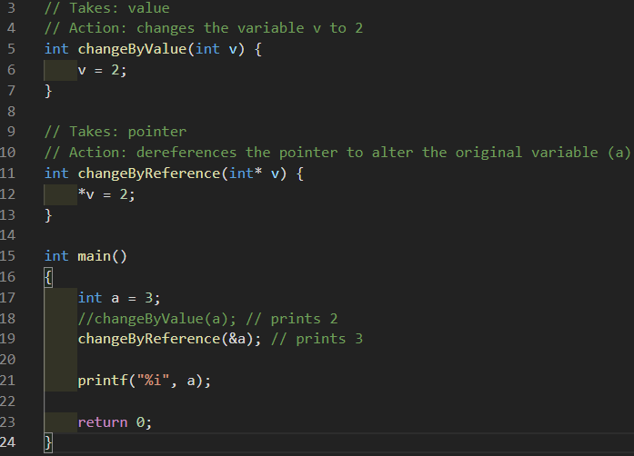
Passing by value will only allow a local value to be accessible to the function via parameters. Passing by reference will give the function access to the original object in memory.

C - Pointers
A pointer is a variable which stores the memory address of another variable. You declare a pointer by using the asterisk * before the variable name. You can use the ampersand & to access the address of the variable which follows.

int a = 3;
int *b = &a;
// b now stores the address of a ( & = address-of )

// Access the value of the pointer by dereferencing it first
printf("%i", *b); // prints 3

// to change a via b, dereference the b pointer
*b = 2;

printf("%i", a); // prints 2

If a pointer is uninitialised, it will contain a random memory location, and the dereferenced value will be random. This will sometimes crash the program with a Segmentation fault. It's bad practise to leave a pointer uninitialised. Always give it a value, or specify NULL.

Mutable vs Immutable
A data type is considered immutable if their value cannot be changed after creation. Immutable objects are thread-safe, meaning that multiple threads can try to access the contents of an object, as they wont change after creation.
If an object is immutable, you should create a reference to this object instead of copying the object. This conserves memory, as references are always cheaper than another duplicate object in memory.

